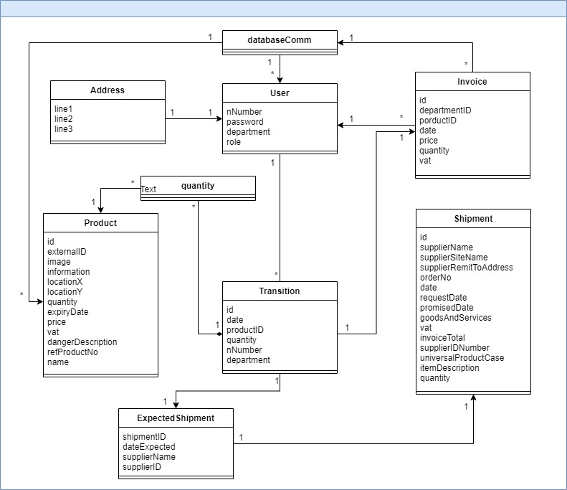

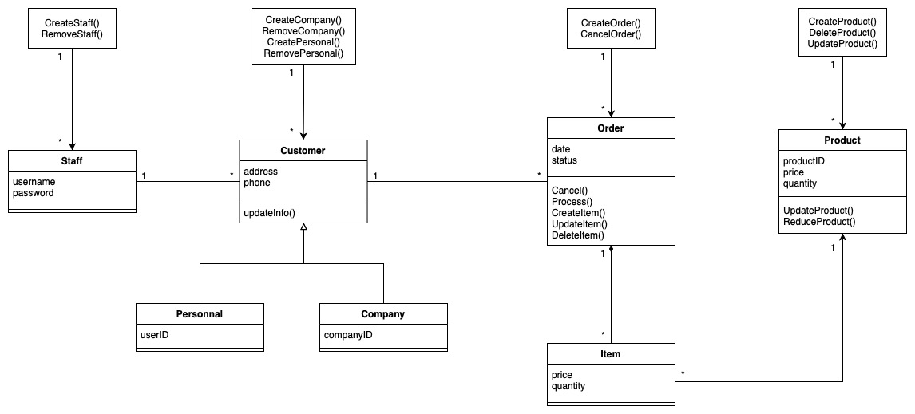

As shown in the figure, when the program runs, the database will import user data and product data. Each user will only have a corresponding address but can create countless orders. Each order will be followed by an Invoice and a shipment. Invoice will store it in the database and send it to the user. On the other hand, an expected shipment will be provided between users for filling in.